Fishways—Managing our waterways (Years 7 and 8)
  - Lesson plan
Victorian Curriculum F–10 links:
Levels 7 and 8
Geography
Geographical Knowledge
Water in the world
Classification of environmental resources and the forms that water takes as a resource
Ways that flows of water connect places as they move through the environment and the ways this affects places
Landforms and landscapes
The spiritual, cultural and aesthetic value of landscapes and landforms for people, including Aboriginal and Torres Strait Islander peoples, that influence the significance of places, and ways of protecting significant landscapes

Introduction

Dights Falls is an artificial weir built on a natural rock bar across the Yarra. Dights Falls is located on the border of Abbotsford and Clifton Hill downstream of the junction of the Yarra River with Merri Creek. This is the place where saltwater meets the freshwater flowing downstream in the Yarra River.

Originally, Dights Falls was one of the narrowest parts of the lower Yarra River. This made the Dights Falls site ideal as a camping ground for the Yallock-Bullock clan (Wurundjeri tribe) of the Woiwurrung Aboriginal people. Clans would meet here and trade together.

The weir at Dights Falls is a barrier to the native fish that need to migrate upstream to breed. A fishway was built to allow the fish to move upstream past the artificial barrier.

Student worksheet

Activity 1: A history of Dights Falls
Students explore the history of Dights Falls including the importance to the Wurundjeri people, the traditional owners of the area.

Activity 2: How does Dights Falls impact on the river environment?
Students investigate the impacts that the weir construction had on native fish populations and role of the fishway in reducing these impacts.

Student worksheet: Fishways—Managing our waterways
Introduction
Dights Falls is an artificial weir built on a natural rock bar across the Yarra. This is the location where saltwater meets the freshwater flowing downstream in the Yarra River.
Originally, this location was at one of the narrowest parts of the lower Yarra River. This made the Dights Falls site ideal as a camping ground for the Yallock-Bullock clan of the Woiwurrung Aboriginal people. Clans would meet here and trade together.
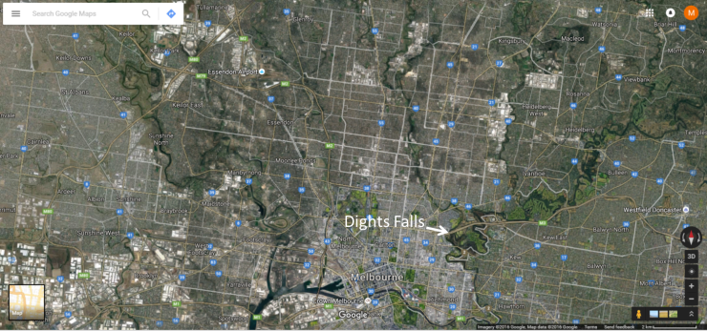
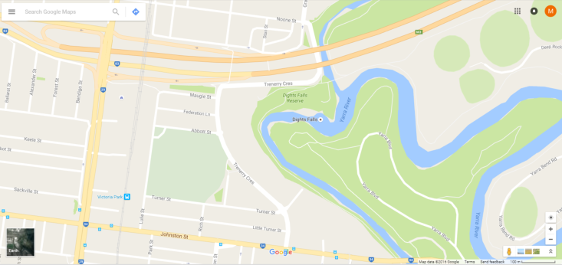
Figure 1 Location of Dights Falls
Dights Falls is located on the border of Abbotsford and Clifton Hill downstream of the junction of the Yarra River with Merri Creek.

Activity 1: A history of Dights Falls
Discover the history of Dights Falls, including the importance to the Wurundjeri people, the traditional owners of the area.
Aim: To present the history of Dights Falls in a digital timeline.
- Go to http://www.timetoast.com/. Look at some of the examples of timelines on the home page. You’ll notice that the most interesting timelines have photos and maps as well as text.
- Work in pairs to produce a timeline using the information about the changes at Dights Falls at <https://vhd.heritagecouncil.vic.gov.au/places/2>
- Use some of the images provided here or find some others by doing an Internet search. Remember to always acknowledge the image source.
- Provide your teacher with a link to your timeline.
You can revisit your timeline to add more information about the present and to outline your predictions for the future.

Activity 2: How does Dights Falls impact on the river environment?
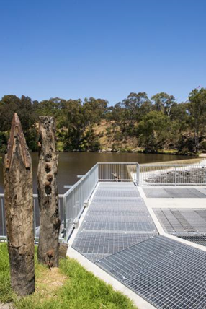
Before the weir was built, native fish were able to make their way around the natural rock structures and move upstream to breed. Many of these native fish rely on this migration as part of their breeding cycle. This was made difficult with the weir’s construction. A fishway allows the fish to move upstream past the artificial barrier.
Watch the video to answer the questions that follow.
This link includes a video which shows an overview of the fishway project: <https://www.youtube.com/watch?v=h3qPVJ9kCLU>
Now you’ve done some research, please answer the following questions:
- For what purpose was Dights Falls first built?
- What affect does Dights Falls have on water upstream? How does this change the river environment?
- Why was there a need to build a new wall?
- Describe the importance and benefits of the fishway to the species of fish in the Yarra River.
- Create your own diagram to show how the fishway works. Use coloured arrows to show the movement of fish through the fishway.
- What was wrong with the old fishway built from rocks?

Victorian Curriculum and Assessment Authority (VCAA) <http://victoriancurriculum.vcaa.vic.edu.au/> Accessed 14 August 2016.

